Tasks of App Server & Web Server
Task 1:Install Apache and run Apache on port number 82:
- Yum install httpd -y : to install the nginx
- Systemctl start httpd: to start the service
- Systemctl status httpd: to check the status of the service
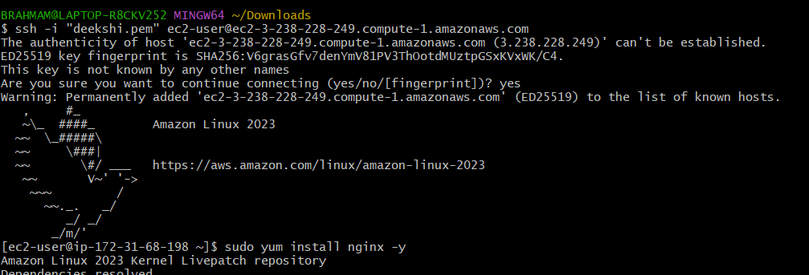
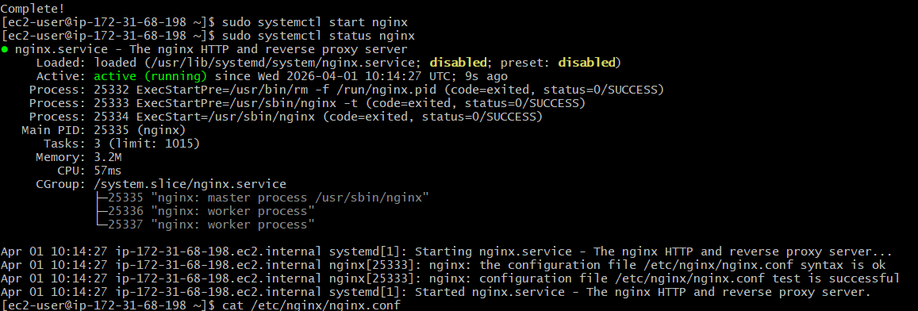
If we have to change port numbers we have to give this command:
- sudo nano /etc/nginx/nginx.conf
we can edit the port number
listen :80 to 81

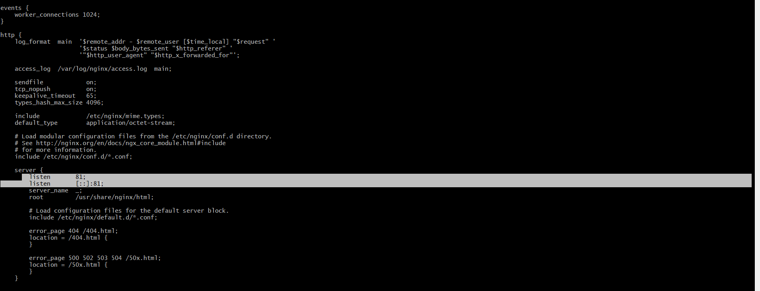
- After port number changing to 81 :
- We have to give again below commands
- Sudo systemctl restart nginx
- Sudo systemctl start nginx
- Sudo systemctl status nginx
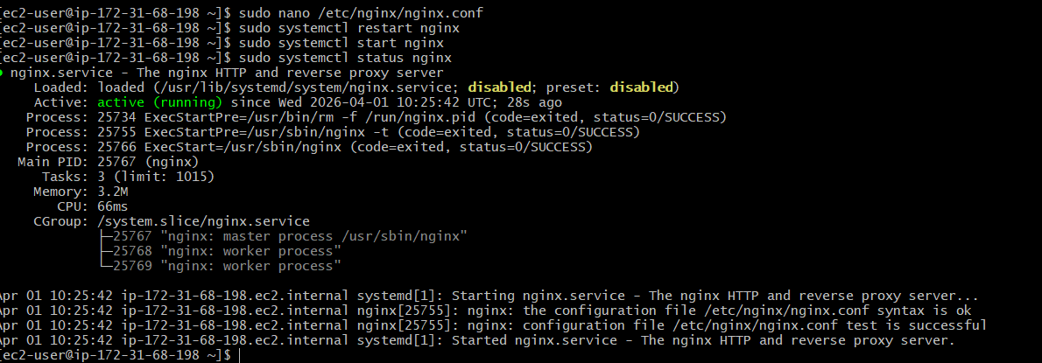
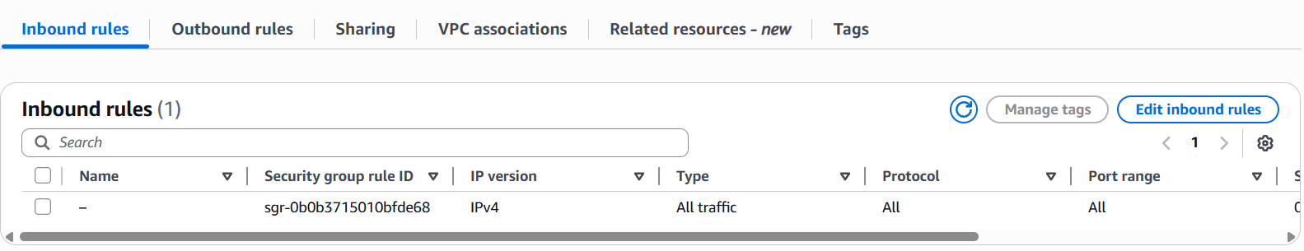
- After changing the port number we have to check security group see type is All traffic or not .If we don’t give All traffic type then we don’t get webpage after changing the traffic type we have to see webpage.

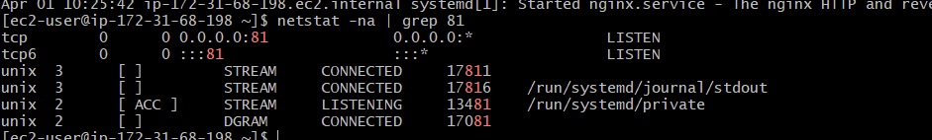
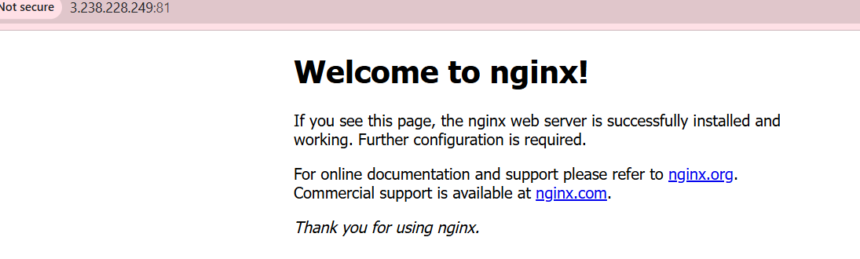
- This is my webpage with port number 81
Task 2) Deploy a sample index.html file on nginx.

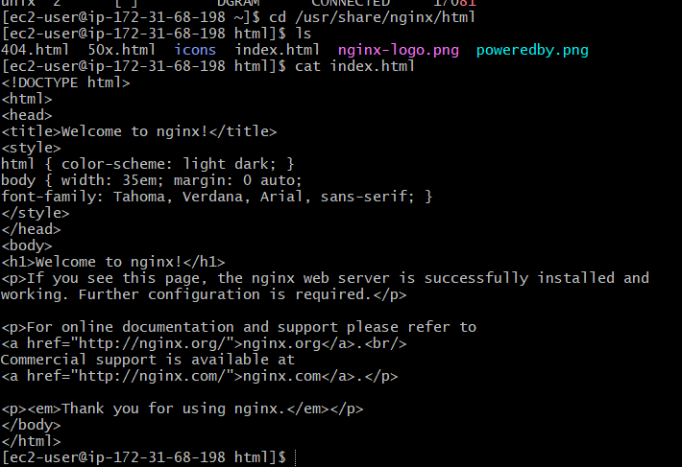
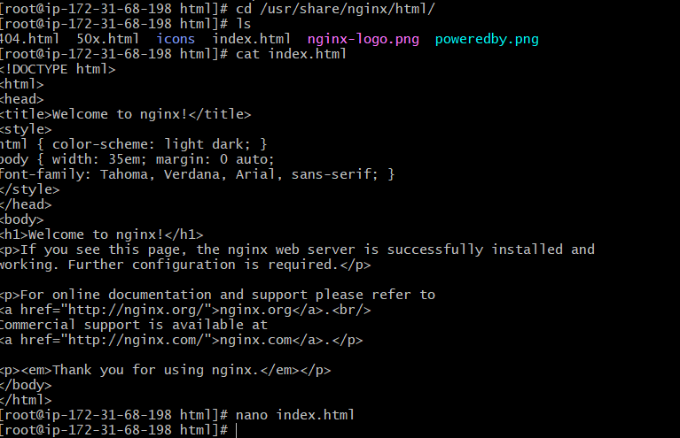
- If we want edit the file we have to give nano index.html
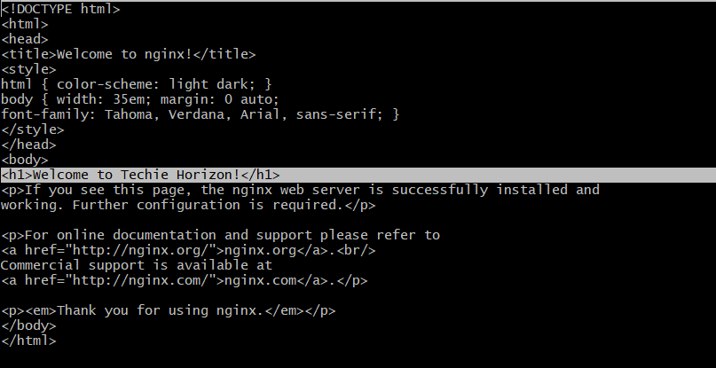
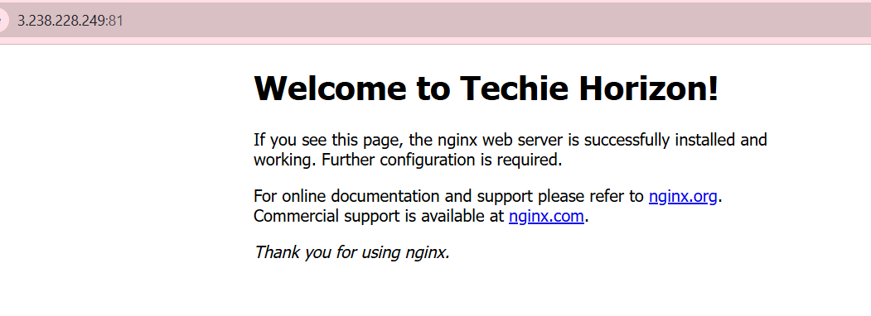

Task 3: Install Apache and run Apache on port number 82
- Sudo yum install httpd
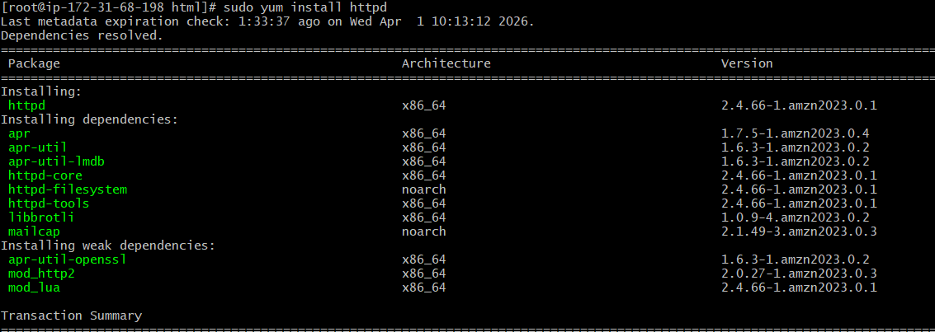
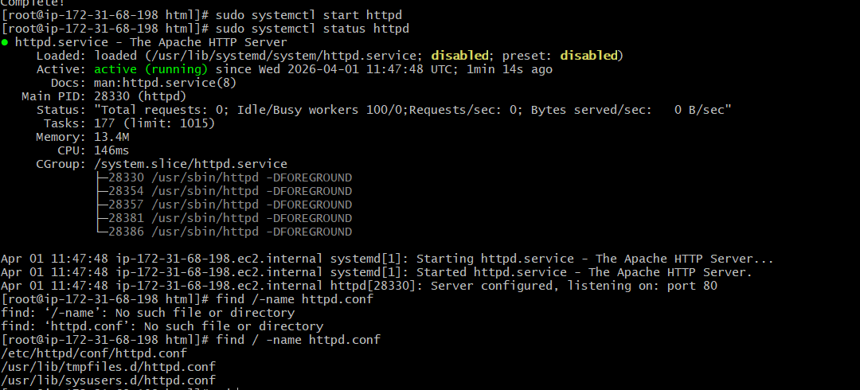
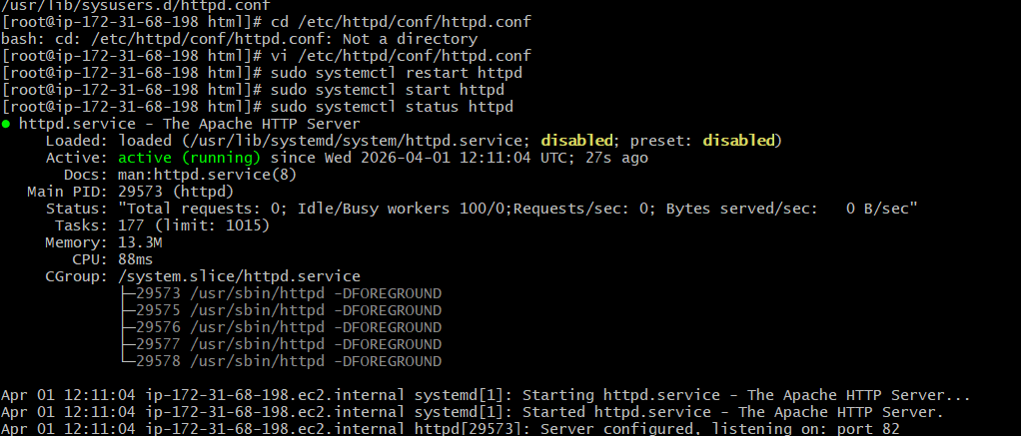
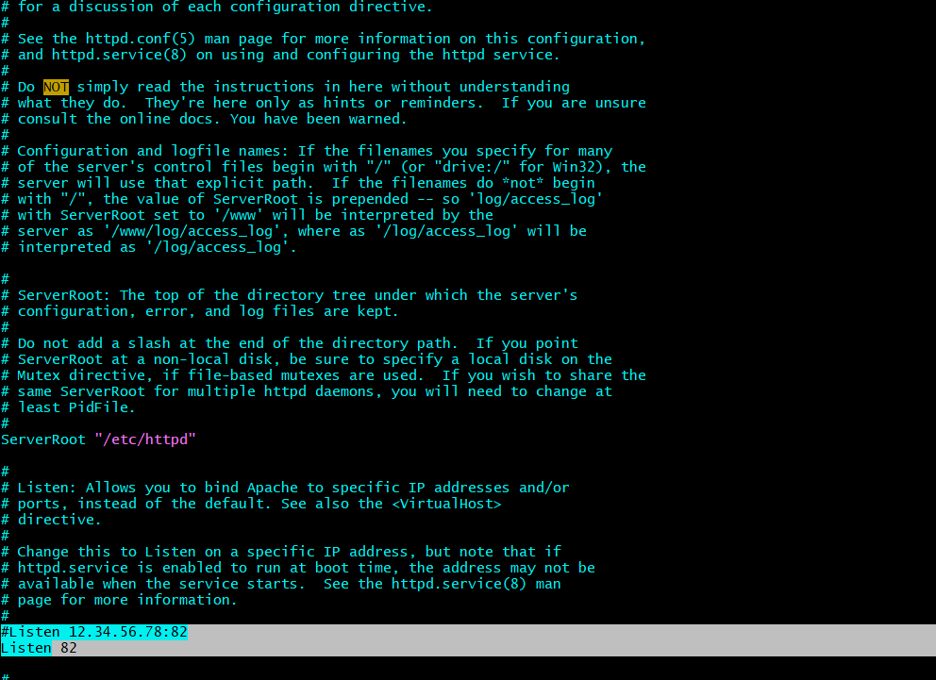

Here we can change the port number to 82.
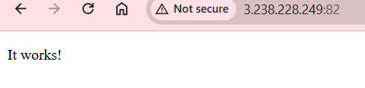
- This is the web browser page with port numbers 82.
4) Deploy a sample index.html file on Apache.
- vi index.html
- We can enter the matter inside this file and we want to edit that file we can use nano index
- Sudo systemctl restart httpd
- Sudo systemctl start httpd
- Sudo systemctl status httpd
- 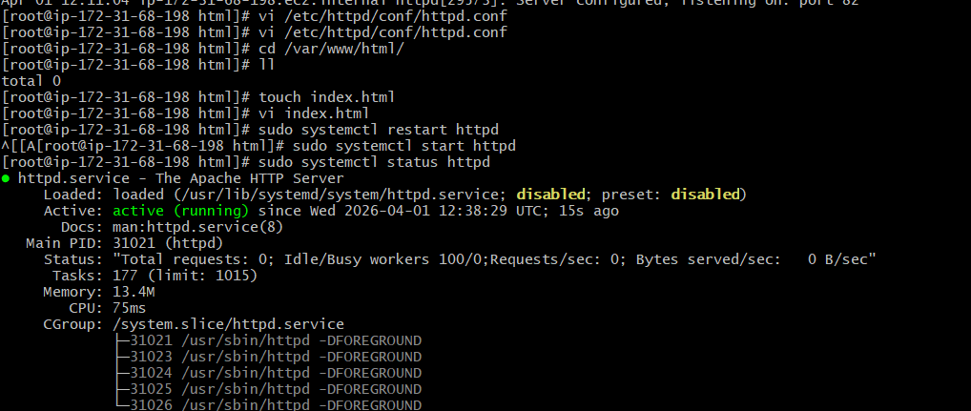

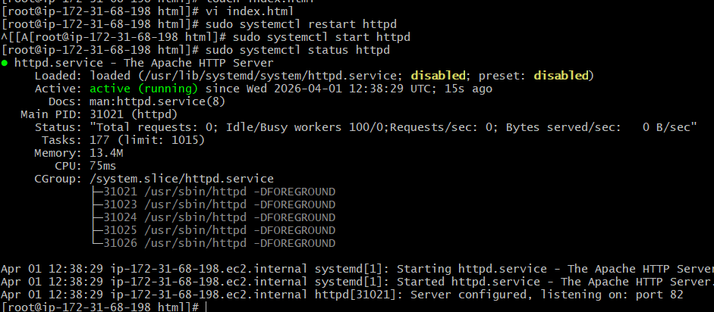
Checking in the web browser:
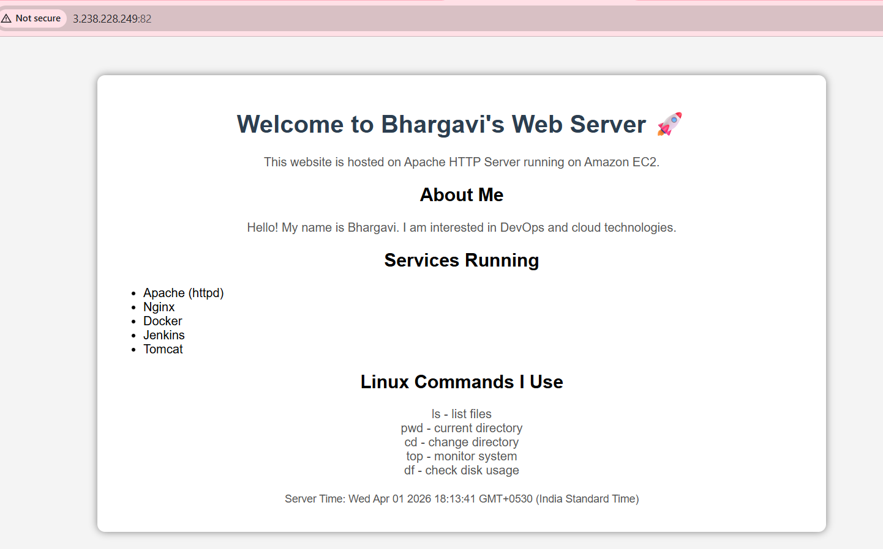

5) Install Apache tomcat on port number 8082
- wget ‘tomcate application link from the browser’: to install the tomcat
- Java is prerequisite of apache tomcat
- Install the java using yum insatll java -y
- ./startup.sh : to start the tomcat
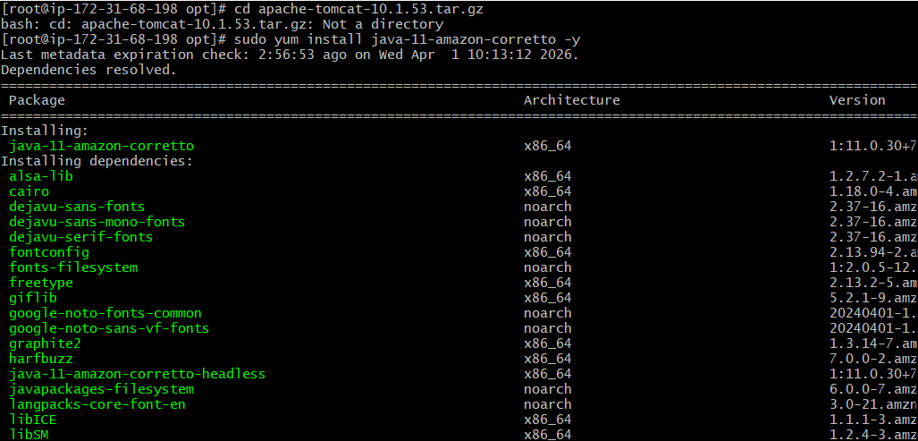
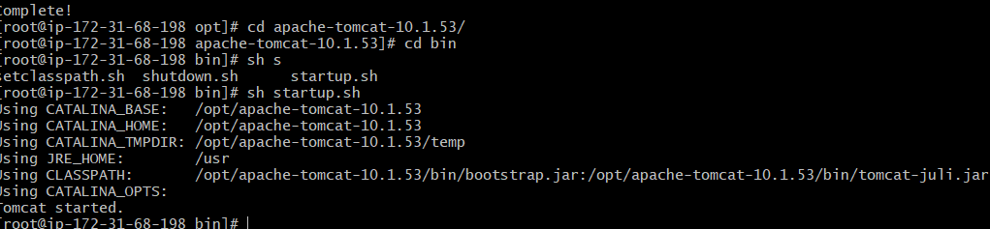
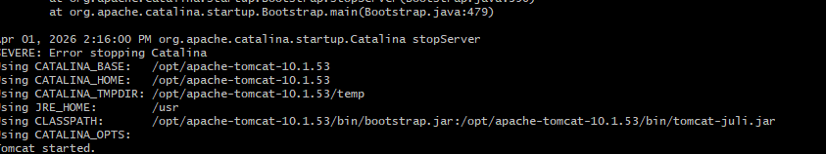
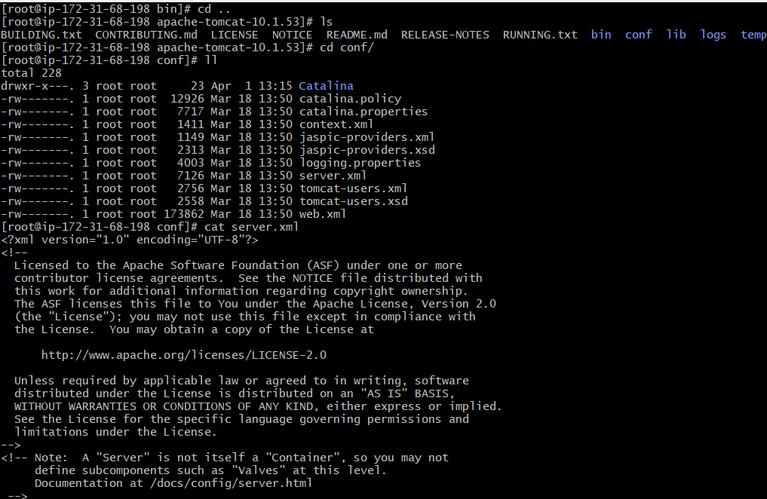
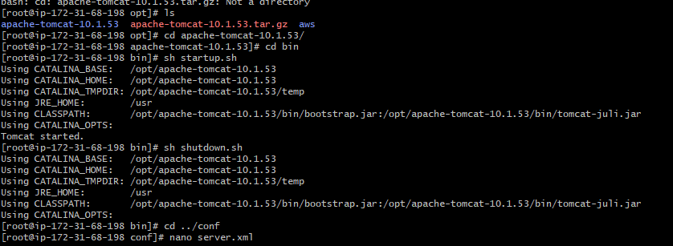
Go to the browser hit the public ip: portnumber:
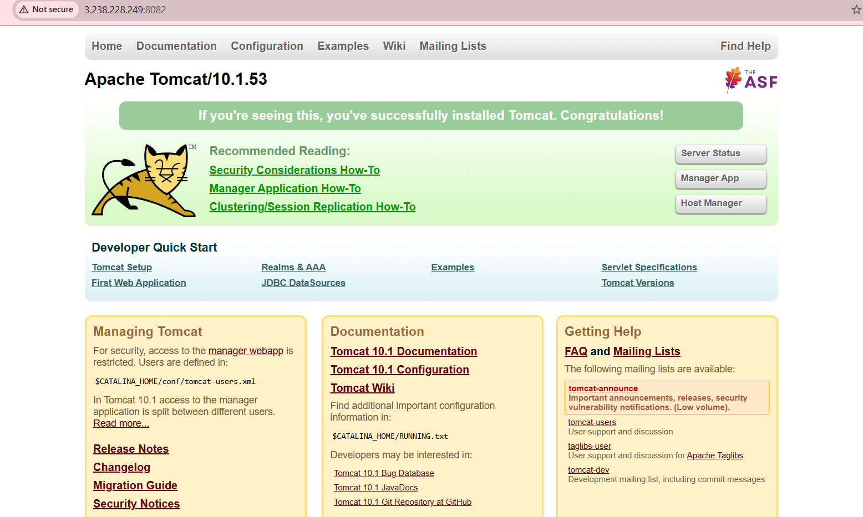
6) Deploy a sample app on webapps
- We have to give ls see webapps new directory is creating it is default file .
- We have to give sample.war link to tomcat command using wget we have to see this deploy a sample app on webapps.

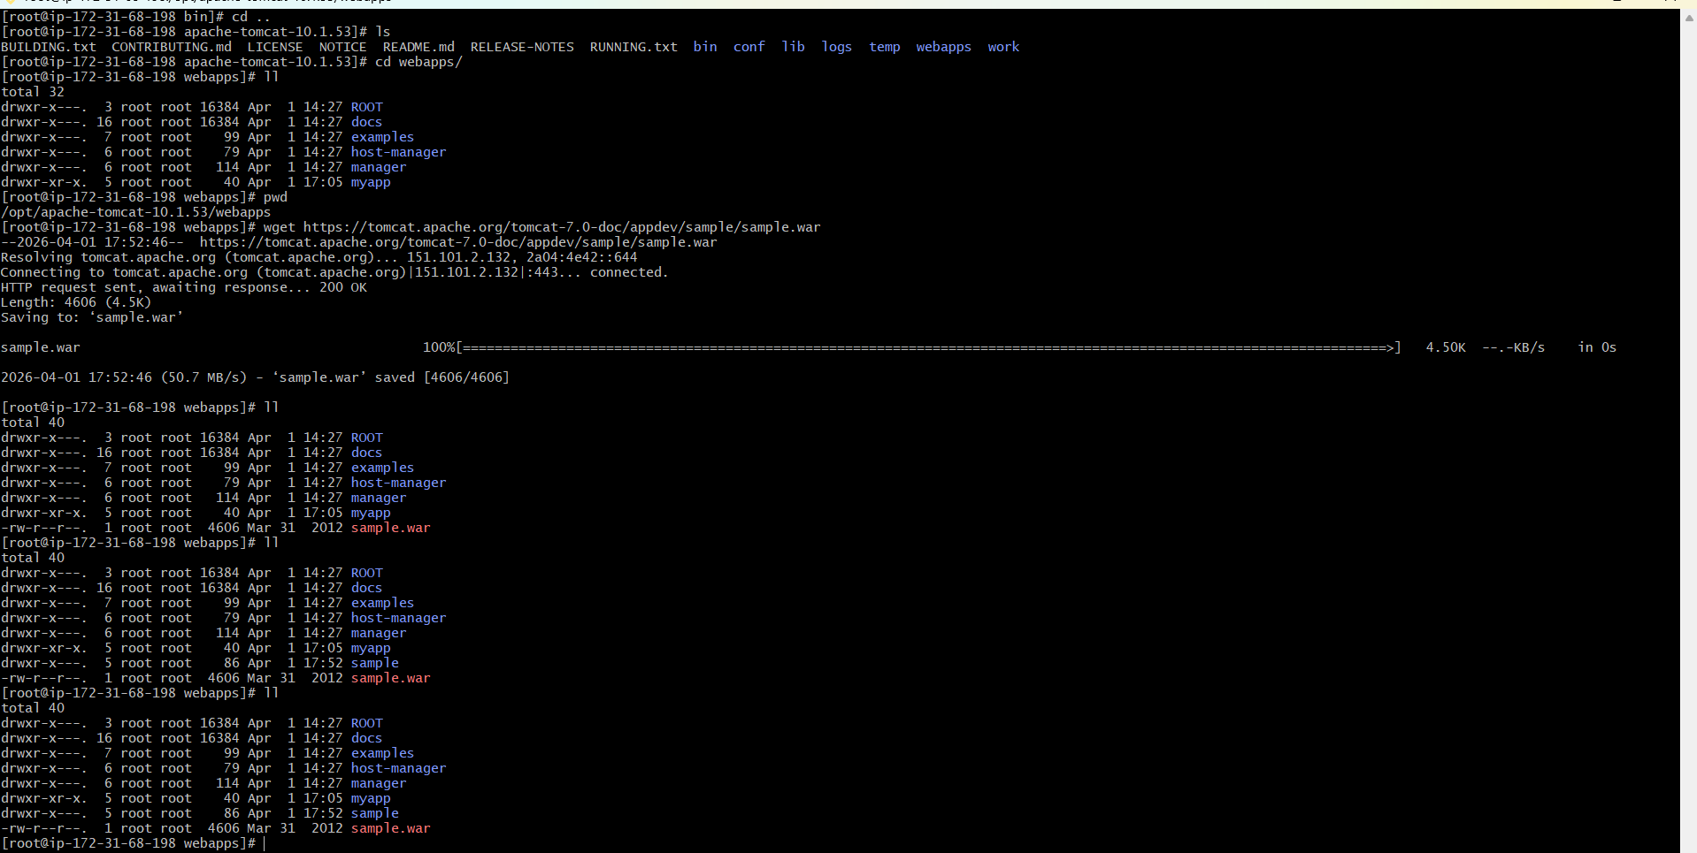
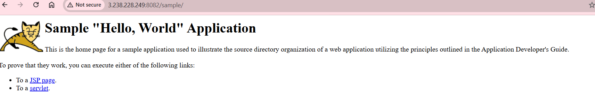


7) Create a tomcat.service file for tomcat.
Use these commands to run this :
- Sudo systemctl daemon-reexec
• sudo systemctl daemon-reload
• sudo systemctl enable tomcat
• systemctl start tomcat
- systemctl status tomcat
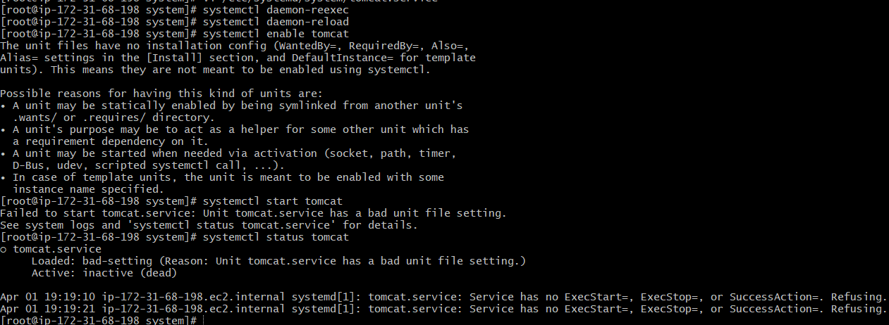

8) Configure HA Proxy server
Steps to follow the HA proxy server
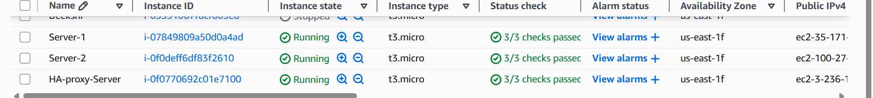
1.SERVER -1 for installation
Sudo -i
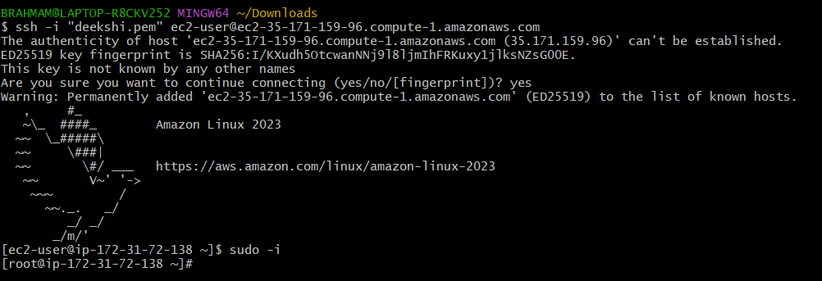

Yum update -y
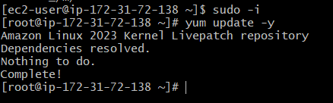
Vi /etc/hosts
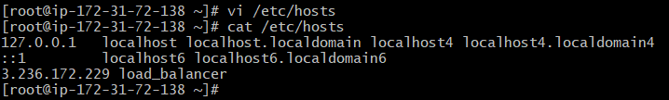
In that vi /etc/hosts
- We have to enter the HA-proxy-Server public IP Adress
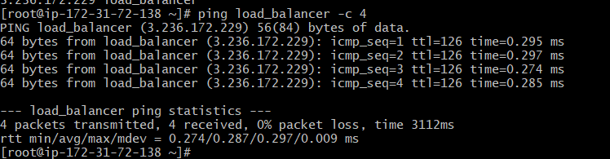

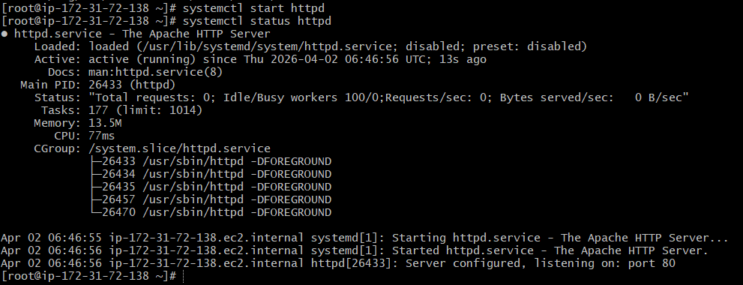
Browser with server1 port no:80 it will work
Server-2 Steps:
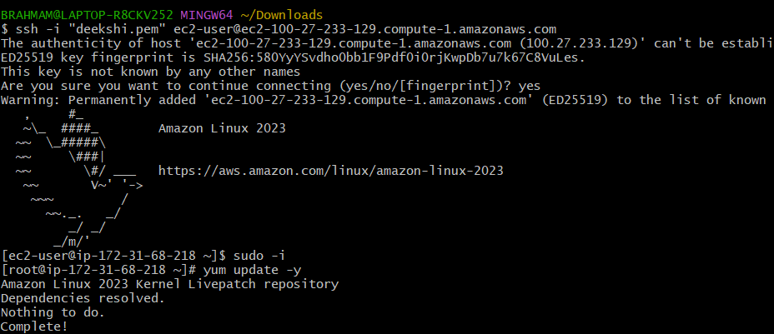
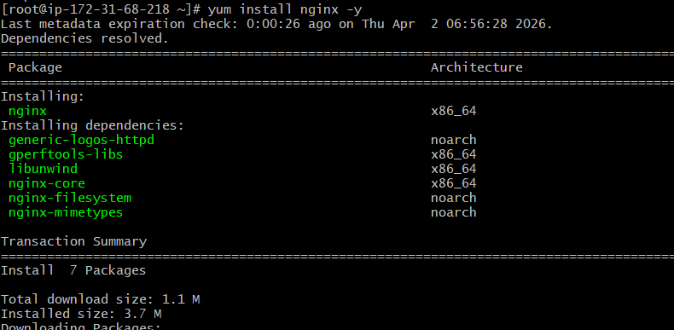
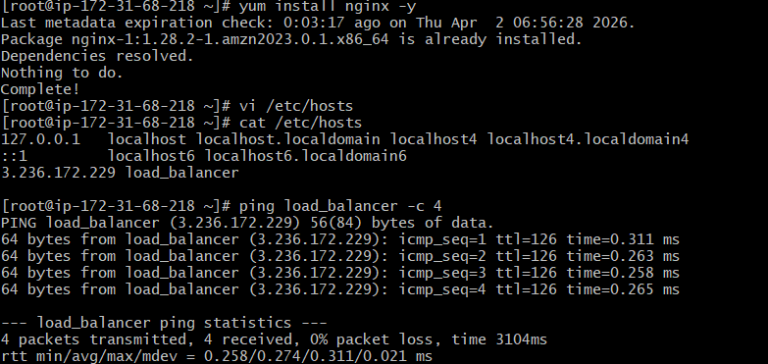
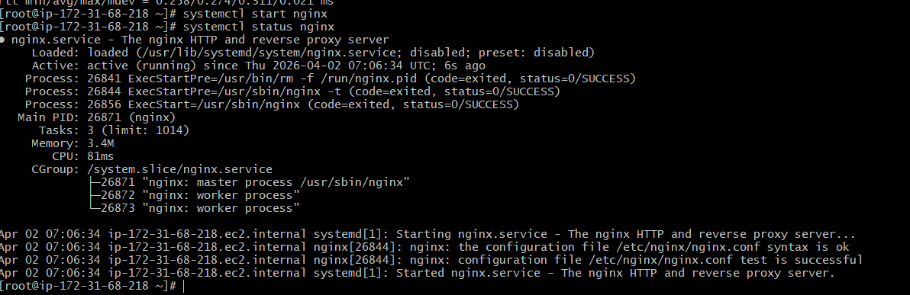
Browse with Server-2 Public IP address:80 it will work
HA-Proxy-Server Steps:
Run following command to Access HA-Proxy-Server
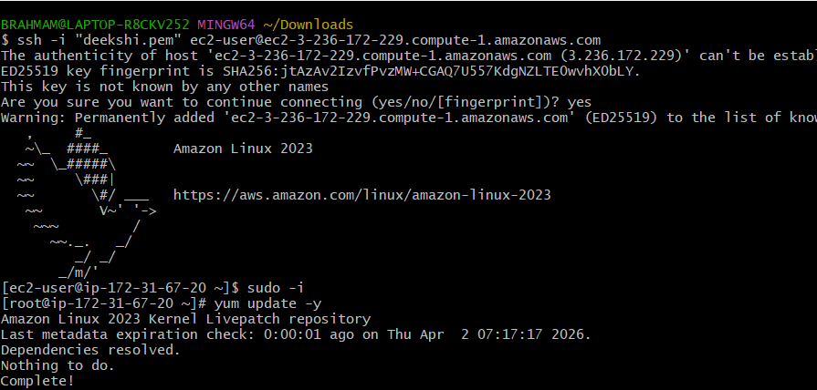
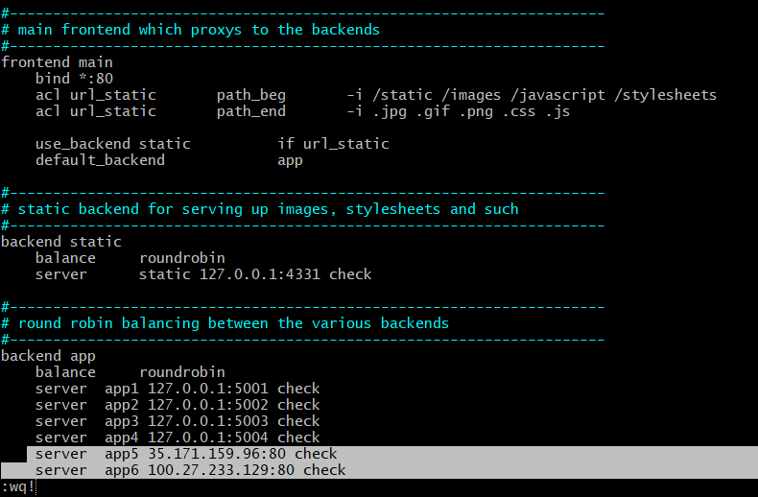
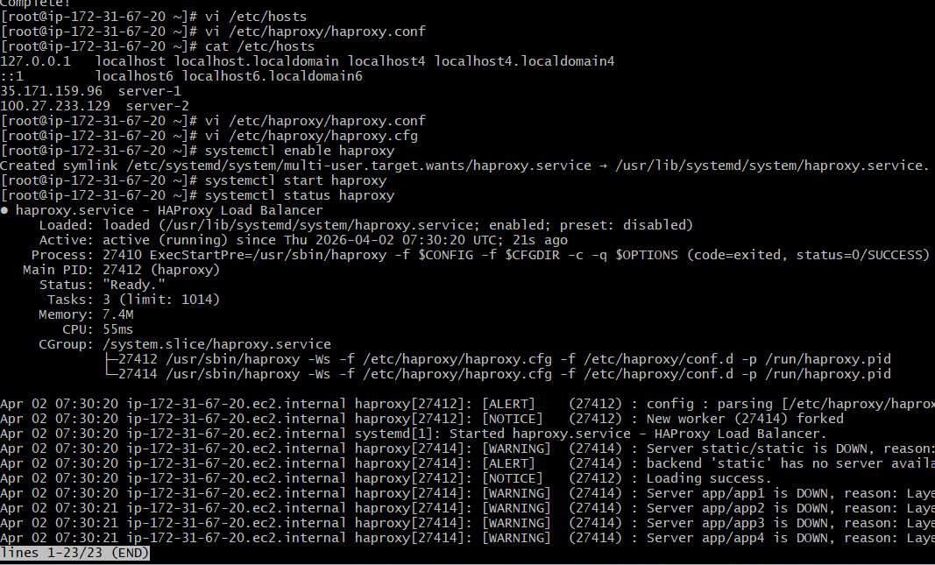
• Now browse with HA-Proxy-Server PublicIP:80 it will distribute load to Server-1, Server-2

